COM535 Cyber Security Lab – Hacksplaining & Tryhackme

Instructions

- Visit https://www.hacksplaining.com/lessons

(Register for a free account if you wish to track your progress – not compulsory however).

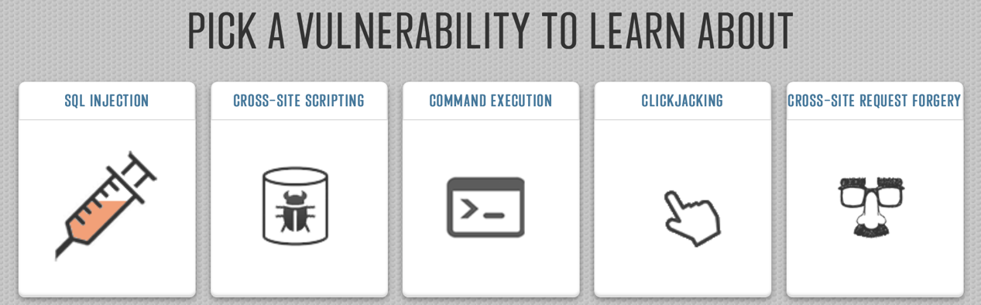

- Complete the first five vulnerability lessons which are:

- SQL Injection - https://www.hacksplaining.com/lessons/sql-injection/start

- Cross-Site Scripting - https://www.hacksplaining.com/lessons/xss-stored/start

- Command Execution - https://www.hacksplaining.com/lessons/command-execution/start

- Clickjacking - https://www.hacksplaining.com/lessons/click-jacking/start

- Cross-Site Request Forgery - https://www.hacksplaining.com/lessons/csrf/start

Tryhackme

- Visit https://tryhackme.com/ and register for a free account. Register multiple in future if you hit time limits. It’s free.

- Complete the following:

- Offensive Security introduction: https://tryhackme.com/room/offensivesecurityintro

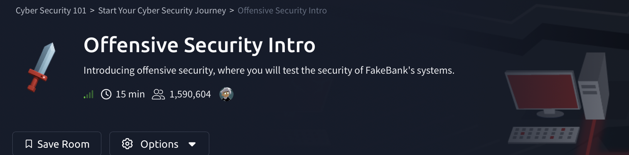

Offensive Security Walkthrough video https://www.youtube.com/watch?v=EcVD3jXSFR0

- Vulnersity - https://tryhackme.com/jr/vulnversity



Help on Vulnversity Walkthrough video https://www.youtube.com/watch?v=VoY2ERH08Bs

c. Traffic Analysis Essentials https://tryhackme.com/jr/trafficanalysisessentials



Traffic Analysis Walkthrough Help video: https://youtu.be/X2k5gNxDY6o

